**Project Design Phase-I**

**Solution Architecture**

|  |  |
| --- | --- |
| Date | 13 October 2022 |
| Team ID | PNT2022TMID39342 |
| Project Name | Hazardous area monitoring for industrial plant powered by IOT |
| Maximum Marks | 4 Marks |

**INDUSTRIAL PLANT:**

An accident occurs in an industrial plant and an alarm sound to be alert.

The industrial plant area is surrounded by people and thus there are many dangerous areas. So, people should be kept in separate place.

If the waste material in the industrial plant is not exported, the disease will come and it will affect the people in the area.

**HAZARDOUS AREA:**

If there is a failure in a hazardous area inside an industrial plant, there is loss of production, human loss, loss of property etc.

So, if the industrial plant is in a private place, there will be no problem.

**RADIATION WAVE:**

Radiation in an industrial plant can affect people if it emits a certain limit.

The radiation emitted by the industrial plant can be protected by sensor to protect people from spreading too much.

**EXAMPLES:**

The solution architecture is gassed multiple monitoring nodes and making use of an embedded controlling device (Raspberry Pi), which gathers the data generated like temperature sensors and gas detectors. A cloud platform is need to visualize and analyse the data thus generated and thereby enabling us to perform rent time tracking and implement a warning system, notifications through the cloud or an audible alarm.

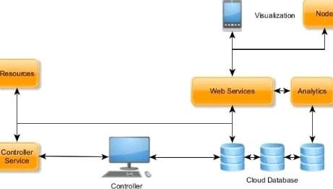

**MINIMUM VALUE PRODUCT:**

**DESIGN:**

A hazardous area (also known as a potentially explosive atmosphere) exists

when a mixture of air gases, vapours, mist, or dusts combines in a way that can ignite under certain operating conditions. Ignition sources in this instant may include impact or friction sparks, electrical sparks, high surface temperature and electrostatic discharge, among others.

**USABLE:**

The monitoring of the hazardous areas in industrial plants is more important

from time to time. If the damage that occurs in hazardous areas can result in the loss of property or lives. So, monitoring of such areas can help in easy monitoring of the hazardous areas.

**RELIABLE:**

All the products coming out through the industrial process are of quality.

**FUNCTIONAL:**

Through functional safety, it is possible to quantify the

probability of a hazardous event taking place and what the consequences would be.